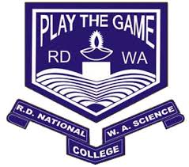

**Department of Computer Science**

**R.D & S.H. National College of Arts and Commerce &**

**S.W.A. Science College**

**University of Mumbai**

**BUSINESS INTELLIGENCE AND BIG DATA**

**(MINING MASSIVE DATA SETS)**

**MSc – Part 2 (Sem III)**

**Computer Science**